Happy Mother's Day

With Love
Kristen & Amanda

Happy Mother’s Day
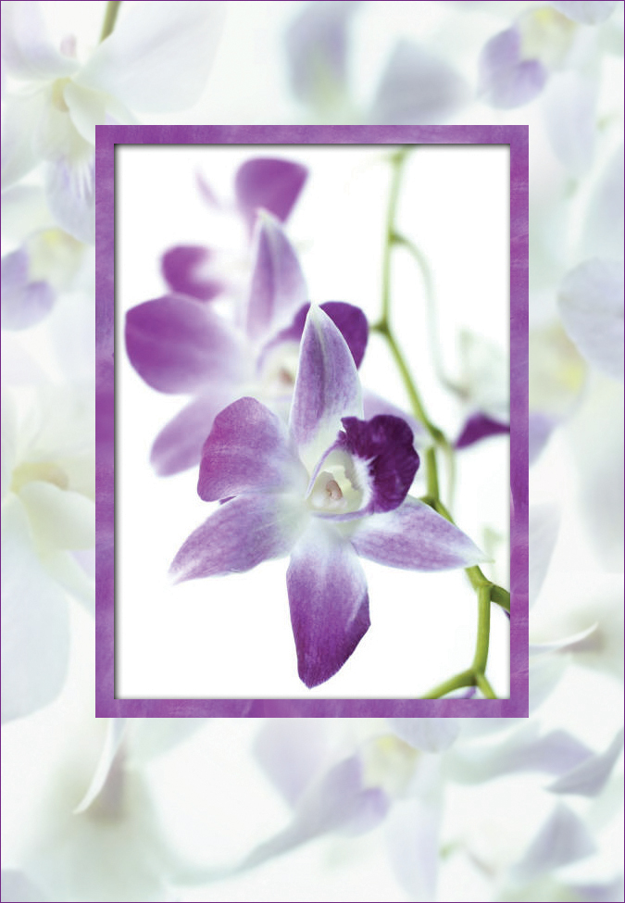

with much love,

Thank you for all your
love and encouragement
over the years
