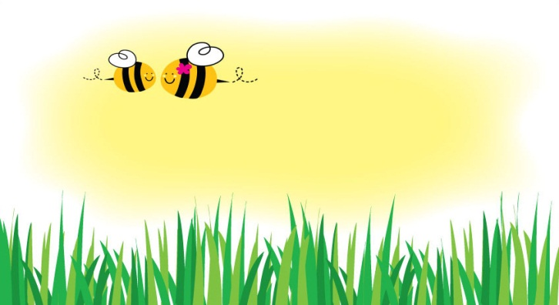
Gift Coupon
Good for ________________
Love, _____________
Gift Coupon
Good for ________________
Love, _____________

Gift Coupon
Good for ________________
Love, _____________

Gift Coupon
Good for ________________
Love, _____________

Gift Coupon
Good for ________________
Love, _____________

Gift Coupon
Good for ________________
Love, _____________

Gift Coupon
Good for ________________
Love, _____________

Gift Coupon
Good for ________________
Love, _____________

Gift Coupon
Good for ________________
Love, _____________

Gift Coupon
Good for ________________
Love, _____________

