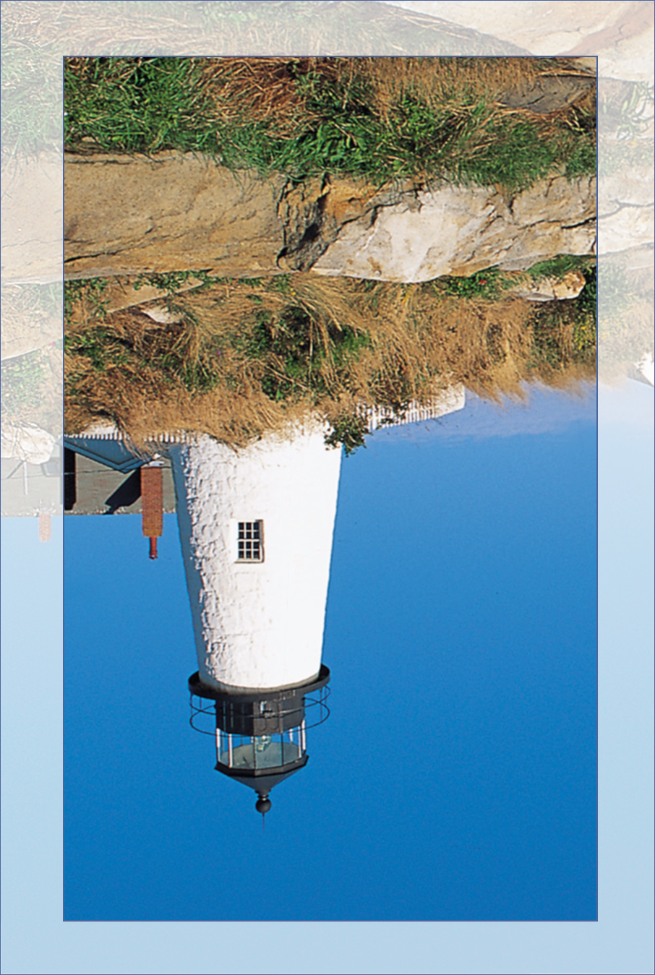

A father is neither an anchor to hold us back,

nor a sail to take us there,

but a guiding light whose love shows us the way.

I love you.

Happy
Father’s Day

