Thanksgiving Party Treats

Chocolate and Pumpkin Spice Acorns

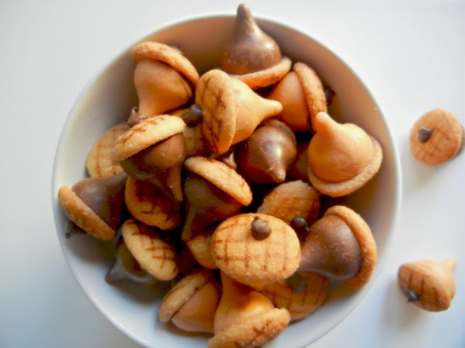
Fall weather is finally here and the leaves are falling and we’ve got a ton of acorns all over the lawn which means a lot of squirrels are running around also!

Edible acorns are great party pleasures and they are so simple to make with Hersey’s Kisses that are in chocolate and pumpkin spice this time of year.

Ingredients:
- 1 Package of Chocolate Kisses
- 1 Package of Pumpkin Spice Kisses
- 1 Package of Mini Vanilla Wafers
- 1 Edible Food Writer
- 1 Package of Baker’s Chocolate

Instructions:
- Melt the Baker’s Chocolate in a melting pot and then place the mini vanilla wafers on a sheet of wax paper (flat side up).
- Place just a dab of melted chocolate on the flat end of the Hershey’s Kiss and then immediately place on the flat side of the mini vanilla wafer. Repeat these steps until you have as many acorns as you want for your Thanksgiving Party.
- After the melted chocolate has hardened onto the mini vanilla wafers then you can decorate the other rounded end of the acorn with the Edible Food Writer by drawing lines to create squares over it. You can decorate the cap of these acorns any way you want to though.
- Last step, add a little bit of chocolate on top of the acorn for the “stem”.

You now have a bunch of edible and fun acorns for your Thanksgiving Party. The chocolate and vanilla wafers are a really great combo and if you like pumpkin spice you will love the pumpkin spice acorns also. You can also add some to cupcakes for a topper or just simply eat them by the handfuls.

Thanksgiving Party Treats

Gobble Me Up

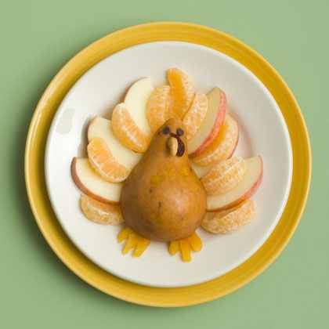
Need a healthy snack for your Thanksgiving Party? If yes, you have to try this treat below.

Ingredients:
- Apple
- Clementine or navel orange
- Pear
- Dried apricot
- Peanut butter or cream chees
- Mini chocolate chips
- Nut (we used a cashew)
- Dried cranberry

Instructions:
- Arrange apple and clementine or navel orange slices on a plate as shown, and lay a cored pear half on top.
- Use scissors to halve a dried apricot, then snip small triangles from each half and tuck them under the pear to form the feet.
- Finally, use peanut butter or softened cream cheese to attach mini chocolate chip eyes, a nut beak, and a dried cranberry snood.

Thanksgiving Party Treats

Marshmallow Pilgrim Hats

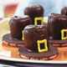
Here’s a treat that looks old-fashioned but is made with two favorite modern-day sweets: marshmallows and chocolate. This will be fun for kids to help you make and they will certainly love them to eat!

Ingredients:
- 24 chocolate-striped shortbread cookies
- Chocolate frosting (Optional instead of chocolate chips)
- 12 ounce package of chocolate chips
- 24 marshmallows
- Tube of yellow decorators’ frosting or gel
- Toothpicks

Instructions:
- Set the chocolate-striped cookies stripes down on a wax paper covered tray, spacing them well apart.
- Melt the chocolate chips in a microwave or double boiler.
- One at a time, stick a wooden toothpick into a marshmallow, dip the marshmallow into the melted chocolate, and promptly center it atop a cookie.
- Using a second toothpick to lightly hold down the marshmallow, carefully pull out the first toothpick.
- Chill hats until the chocolate sets, then pipe a yellow decorators’ frosting or gel buckle on the front of each hat.

Thanksgiving Party Treats

Thanksgiving Turkey Treats

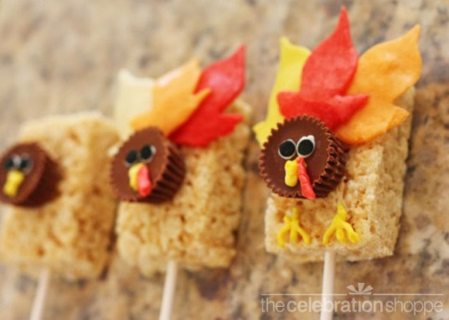
These turkey treats are fun and easy!

Ingredients:
- Box of Rice Krispies Treats
- Starburst Candy (Orange and Yellow)
- Small Package of Mini Reese’s Cups
- Plastic Lollipop Sticks
- Tube of black decorators’ frosting or gel
- Pillsbury White Frosting

Instructions:
1. Insert a lollipop stick in your Rice Krispies Treats.
2. Heat and mold your Starburst candies for the feathers, beak, feet, etc. by heating each individual square in the microwave (on its wrapper) for eight seconds. Lightly (you don’t want it wet because it will take the candy forever to dry) dampen your wax paper and your roller with water so that the candy doesn’t stick, then roll the candy out. Use a leaf cookie cutter to cut out 2 yellow leaves per treat and 1 orange leaf per treat as shown above.
3. Attach your turkey’s face (Reese’s Cup) with two dots of white icing and then two dots of black decorator’s frosting or gel for the eyes. Pipe on a triangle for the beak and little feet out of the left over yellow Starbursts. Also don’t forget the turkey’s beard out of the left over orange Starbursts.

These are fun and enjoyable treats for your next Thanksgiving Party…Enjoy!!

Thanksgiving Party Treats

Thanksgiving Tepee Treats

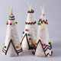
Historically, an indian tepee was made from a cone of long poles and a hide covering that appeared shiny white until the hearth fire cured it. Construct a village of simlarly handsome – thourh edible – tepees with this food craft. This will be as fun to make and they will certainly be fun to eat!

Ingredients:
- Sugar cones
- Confectioners’ sugar
- Unsalted butter
- Vanilla extract
- Cake-decorating icing
- Decorative candies
- Toothpicks

Instructions:
- In a mixing bowl with an electric beater set at low speed, mix 2 cups of sifted confectioners’ sugar, ¼ cup of softened, unsalted butter, and ½ teaspoon of vanilla extract until smooth and spreadable . Stir in a bit of milk, if needed.
- Use the icing to lightly frost eight ice cream sugar cones, then place them in the freezer for a few minutes until the icing hardens.
- Now use tubes of cake-decorating icing to draw linear patterns and images of the tepee and glue on decorative candies with icing. For lodge poles, insert toothpicks into the tip of each cone.

