
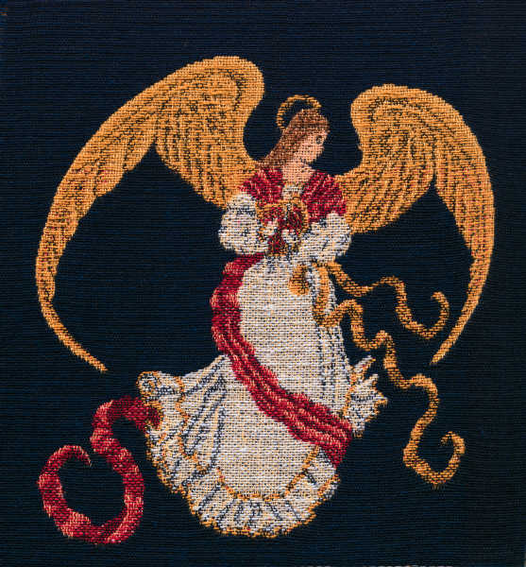
I bring you good news of great joy that will be for all the people. Today in the town of David a Savior has been born to you; he is Christ the Lord.

Merry Christmas

The YourFamilyName

