WARNING!
RISK OF ELECTROCUTION!
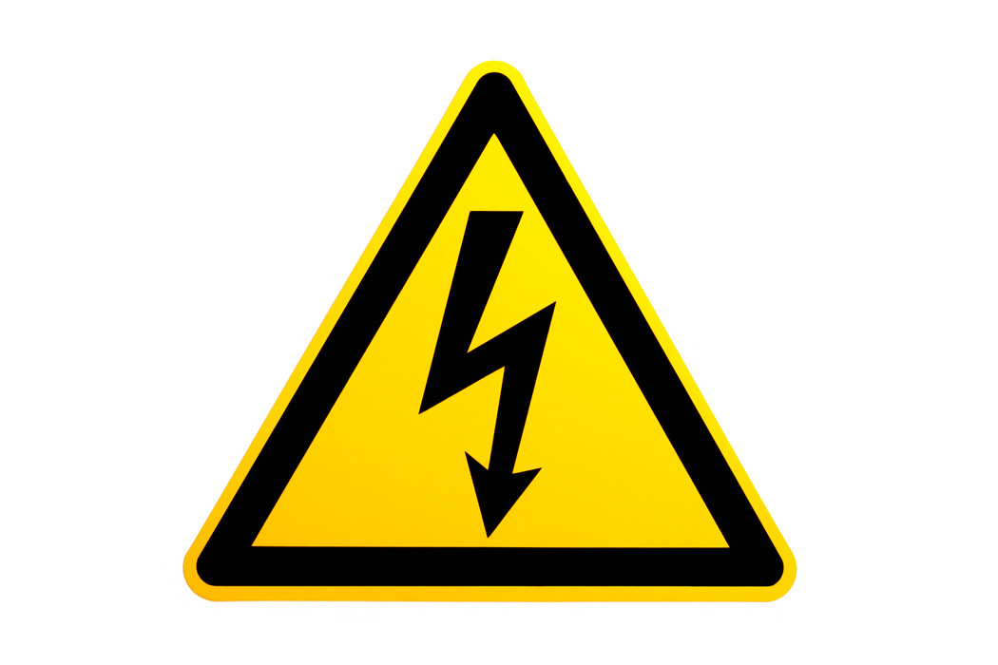
USE SAFETY  GLOVES ALL  THE TIME  WHILE ON  MAINTENANCE | 