Menu |  | - [Company Name]  - Lunch in the Office Fundraiser  - 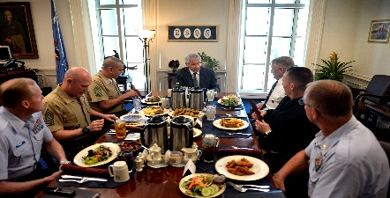  - [Day of Week] – [Date], 2016
 |  | Barbeque Chicken  $8.00 Per Employee  Barbeque Chicken, Mashed Potatoes & Gravy, Green Beans, Roll, Green Salad and Dessert Served with Sweet or Un-Sweet Tea!  Salad Only - $5.00  Fresh Green Salad and all the fixings!  Soda - $1.00  Many different flavors of pop to choose from!  Candy Bars - $1.00  Many different flavors of candy bars to choose from!
  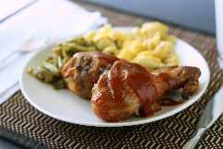
  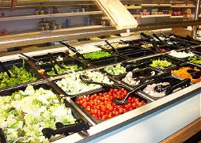
  
  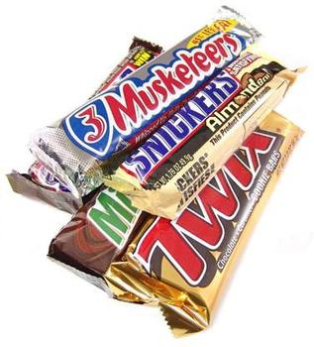
These lunches are also available in nice to-go boxes.

