Store Hours:
10:00 A.M. – 5:00 P.M. (Mon. thru Fri.)
9:00 A.M. – 6:00 P.M. (Sat. & Sun.)

Sale!

Sale!

The Green House
567 Main Street
Branson, MO 65616
(417) 555-0148

Sale prices good through 11/30/13
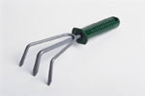

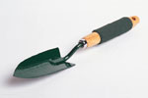
Sale!

Don’t Miss Out on Your Chance to SAVE!
All decorative glassware
20% off!
Pots and baskets
25% off!
Assorted garden tools
starting at $10!


