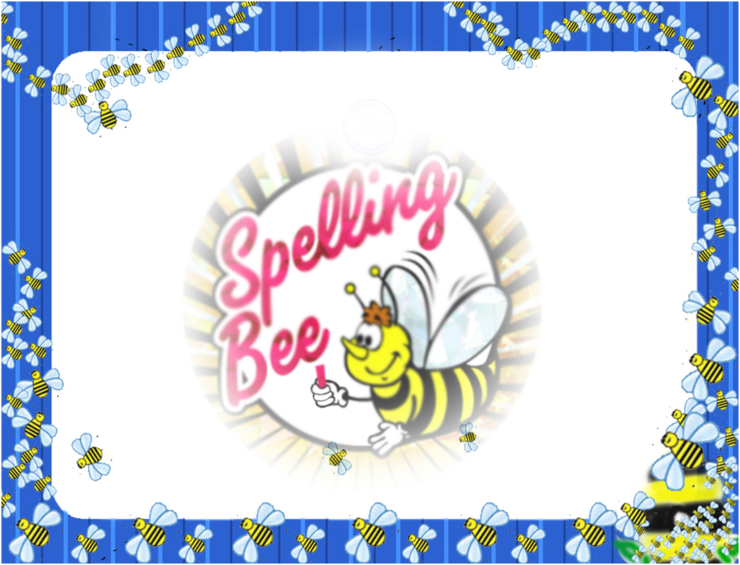
Congratulation !!!

Certificate of Appreciation

This is to certify that,
……………………………………………………..…………………………
Has participated in the Spelling Bee Competition
and has achieved…………………………………… Position

(principal)

